Dry humidifier umbrella for lung cancer and multiple sclerosis patients
Christopher R Aitken, Jaime Martinez Diaz, Jason J Schwarzwalder, Christopher J Barry, Yizhe Wang,Yunke Chen

EXECUTIVE SUMMARY
MANY people have respiratory difficulties that make it hard to breathe in hotter weather. We would like to alleviate this issue by creating an umbrella that has a built-in humidifier to provide cool mist to the user so they can have more freedom without worrying about possible issues breathing. The umbrella will have an integrated design that will include: A cooling system, humidity and temperature detection system, humidifier, control unit, and a power supply with possible power generation by using solar panels. Some goals are not only to keep the cost down, but to also keep the umbrella light and easy to use.

PROBLEM STATEMENT
During the summer, many people that have respiratory difficulties cannot go outside due to the temperature and humidity. They instead are hunkered down indoors near a humidifier, unable to go anywhere. This prevents people from living their day to day lives and stops people from doing something as simple as walking their dog. Our customer would like an easy to use, portable humidifier that would provide cool air in a design of something similar to an umbrella. In the current marketplace, there is no portable cold humidifier that can reliably keep a steady humidity rating and temperature. Simple implementation of humidifiers onto umbrellas have been manufactured by previous companies but lack proper embedded humidity and temperature sensing. Our humidifier umbrella would fill in a niche market of an affordable portable respiratory aid. Target consumers would be lung cancer and multiple sclerosis patients, but broader consumers would want a device to keep them cooler during hot summer days

APPROACH
- Problem analysis & Approaches

Humidity and temperature detection
The device needs to be able to detect the humidity and temperature of the surrounding area. The part of design requires a high sensitivity and veracity.
Approach: We will be using a DTH22 which is a temperature and humidity sensor [1]. This sensor can operate with a 3.3-6v DC power supply and within -40~80 °C. The sensor can only send data every 2 seconds, but this should not become an issue in the final design. The sensor costs $15 [2]. This sensor is both precise and cheap.

Data receiving and system control
In order to make all the desired functions work, the control system is required to receive data stably and effectively. Meanwhile, the size of the whole control system shall be small enough to be integrated into the umbrella structure.
Approach: The Raspberry Pi Zero would be an ideal control board to handle the multiple functions of the umbrella [3]. The DTH22 is directly compatible with the Pi zero, as it only requires some libraries to be installed [1].

Cooling system
There is a rigid demand that the device be integrated with a cooling system. The design of the cooling system needs to meet the required temperature range that the customer specified.
Approach: The material of the umbrella cover will have reasonable defensibility of heat and ultraviolet rays. Two or more mini humidifiers will be integrated into the umbrella to spray a mist to reduce the surrounding temperature. There are two potential pumps to use. The Anself can pump 240 L/H and the Vipe can pump 120 L/H [4]. The Anself is the bigger and more powerful pump, but reviews state that it is notorious for burning out if it is run dry. The Vipe is reviewed better overall but it's a weaker pump [5]. We will be choosing the Vipe due to its lower costs and the reviews state that it is more reliable.

Umbrella construction
The whole umbrella will be highly integrated. The factors of weight, size and durability need to be considered.
Approach: The umbrella will use bubble style, which has about a 51” canopy size and manual opening. The advantage of the bubble umbrella is that it can cover the upper body more effectively than the traditional umbrella. In addition, a bubble umbrella would be the best shape during windy conditions. It is considered as a reasonable shape to ensure the inner area of umbrella stable and let the mist spray naturally down. We will use 3D printing to build some of the structure of the umbrella as well as housing for the electrical components. The filament of the 3D printer has extrusion temperature from 356F to 210F. The PCB design may also be applied because we will have to design a waterproof housing for it.

Power supply
The user specified that a solar panel should be implemented into the design.
Approach: The solar panel that will be used is the uxcell 5Pcs 5V 60mA Poly Mini Solar Cell [6]. It delivers enough power to charge the battery as well as power the circuit. When there is enough voltage coming from the solar panel, it will be used to power the umbrella. If not, the Samsung 20S 18650 2000mAh 30A Battery will be used to power the umbrella [7]. Excess voltage from the solar panel will be used to charge the battery. There will be a diode circuit which compares voltage coming from the battery and the solar panels. Whichever is delivering more voltage will be the one used at that moment to power the umbrella.

Ultrasonic humidifier
The user specified a humidifier in order to aid them with breathing properly in the heat.
Approach: The humidifier type that will be incorporated is an ultrasonic humidifier, in particular the 20mm transducer fogger ceramics discs humidifier [8]. There will be four separate humidifiers placed on the umbrella ribs, on opposite sides of each other. Since the humidifiers are spread out there will be ample surface area coverage to aid the users breathing. They will be controlled from the Raspberry Pi and will be adjusted based on the humidifier sensor reading. A single humidifier operates on 5V 300mA, which will be obtained from solar power supply or the backup battery.

Integrated fan
The user required the humidifier umbrella to lower the temperature. We choose to use an integrated fan to accelerate evaporation and thus cool the air temperature.
Approach: An integrated fan with foldable propeller will be placed at the upper part of the umbrella. The propeller will be able to fold when the motor is off and the umbrella is collapsed. This type of propeller shall be made using a 3D printer. For the motor of the fan, we choose to use a 1.5V to 3V DC motor [9]. This motor runs at a continuous current of 0.09 A, consuming power as low as 0.135 W [9]. Also, its size is small enough to fit in the umbrella rod; with the length of 17mm, width of 9mm, and thickness of 7mm.

- External system diagram

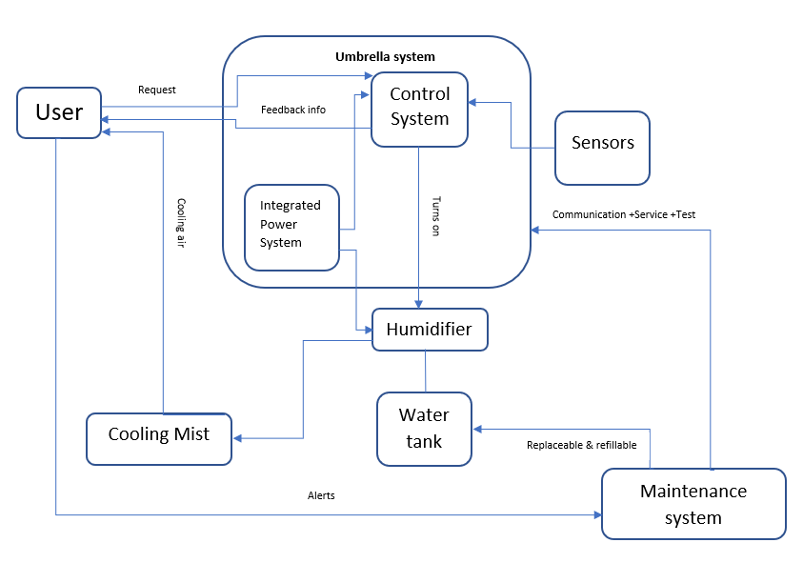
Fig 1. External system diagram

- Alternative approaches
As a backup plan, we may use a different microcontroller if the Raspberry Pi does not provide the functionality that we need. For the cooling system, we currently have two possible solutions: We can attach a fan on the inside of the umbrella or we could put ice into the water tank to have the water be cool or use a thermos as the water tank to keep the water cool. The solution we choose to use will depend on testing these possible solutions. If the DHT22 does not work for our design, we could use the DHT11 [10]. The DHT11 is a cheaper and smaller, but less precise version of the DHT22. An alternative to the small solar cell is JIANG’s Flexible Solar Panel [11]. This design is made of a flexible material that may be a better fit for the opening and closing of the umbrella, which would work better if the umbrella cannot conveniently fold with the small solar cells. An alternative to the Samsung rechargeable battery is Anker’s PowerCore5000 Portable Charger [12]. The downside to using a battery pack is it takes up more volume and doesn’t have the convenience of replacing an uncharged battery with a charged one. The user will always have to charge the battery before use. Though, depending on how much power is required for the whole umbrella, lithium ion batteries may not suffice.
An alternative approach, if the cooling system is inadequate, is to add a fan in between the stretcher and the ferrule. The fan would accelerate the evaporative cooling system, since evaporation occurs through moving air. Four humidifiers position on opposite ribs will provide the needed water vapor to allow effective evaporative cooling as well as keeping the humidity at a comfortable relative humidity. To further increase the cooling potential of the umbrella mounting UV reflective material on the top would reduce the heat absorption of the umbrella. Aluminum has the highest reflective index, making the most suitable cover for the canopy. The downside to this approach would be the loss of straight line access for the control wiring on the handle of the umbrella to the Raspberry Pi, which is located on the top ferrule. The additional wiring would alter the closing mechanism of the umbrella, limiting the running length of the stretcher. The water pump would be placed inside of the water tank to prevent it from operating dry, causing overheating and wearing of the pump. Water tubes connecting the pump and humidifiers would be split into four to allow proper distribution of the water. Proper filtration would be put on the intake of the water pump to prevent any unwanted minerals.

- Introduction to background knowledge/phenomenology supporting the project
1. The canopy of the umbrella shall be made by material that has a high reflectivity to sunlight. Thus, most of the thermal energy carried by the sunlight will be reflected, not absorbed by the human body [13]. Somatosensory temperature will be lowered.
2. Vaporizer will spread water in the air, thus increasing the humidity in the air.
3. Evaporation of liquid water absorbs heat [14]. The water nebulizer integrated in the device can spread water droplets in the size of micrometers; greatly increasing the contact area between water and air. This accelerates the process of gasification of water and lowers the temperature.
4. When the water temperature is lower than the outside air, heat exchange will result in the transmission of thermal energy from air to water [14]. This process will lower the temperature of the air.
5. An air fan integrated in the device will result in a faster air flow [15]. It will accelerate the evaporation of water and heat exchange between air and human skin, both of which will decrease the somatosensory temperature.
6. The solar panels will have precedence to power the umbrella over the rechargeable battery. This will conserve the battery life as much as possible. Extra voltage from the solar panels will be used to charge the battery in addition to powering the umbrella. When the solar panels cannot supply enough voltage, the umbrella will rely on the battery for power. While the battery has sufficient battery life, the RGB LED will display a green light. When the battery drops below a certain amount, the RGB LED will display a red light.

- Project requirements specification
1. Input/output Requirements
(1) The umbrella integrated humidifier shall start or end functioning when the input signal from a button is received as the user push the button on the umbrella.
(2) Battery level of the device shall be indicated using an RGB LED.
(3) The humidity level shall be detected by a humidity sensor.
(4) The temperature shall be detected by a temperature sensor.

2. Functional Requirements
(1) The device shall be an umbrella-integrated cold humidifier.
(2) The device shall shade an area with lowered temperature to 65-70 °F.
(3) The device shall provide humidified air within 30% - 60% relative humidity for the user.
(4) The device shall function 1~2 hours on a single battery charge.
(5) The device shall provide an all-direction cooling and humidifying in the area when it is in normal mode.
(6) The device should run a low-power mode when the battery is low.
(7) The device should provide single-direction cooling and humidifying when it is in low-power mode.
(8) The device should either fogger vision or water-spray vision.

3. External Interface requirements
(1) The water tank shall be easily refillable, and the refill process shall be less than 1 minute for the user.
(2) External water tank should be attached to the device to provide extra water.
(3) The battery should be rechargeable using USB adapters.

4. Technology and System-Wide Requirements
(1) The umbrella shall be portable and within the size of 50’’ arc and 36’’ length.
(2) The weight of the device shall be within 1.5 lb, which means being light enough for people to hold for 1~2 hours.
(3) The device shall be integrated with solar panels.
(4) The device shall use a Raspberry Pi Zero as central processing unit.
(5) The cost of the device shall be under $100.
(6) The device shall be durable for 100 times or 150 hours of daily use.
(7) The device shall be functionable with outdoor temperature from 65 °F to 70 °F (18.3 °C to 21.1 °C).
(8) The device shall be functionable with water temperature from 32 °F to 95 °F (0 °C to 35 °C).
(9) The operation noise of the device shall be less than 40 dB.
(10) The device should be integrated with an air fan.

SYSTEM DESIGN
- Functional decomposition

Level 0
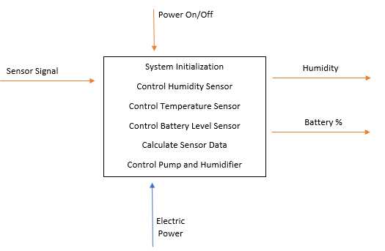
Fig.2 System design level 0

Level 1
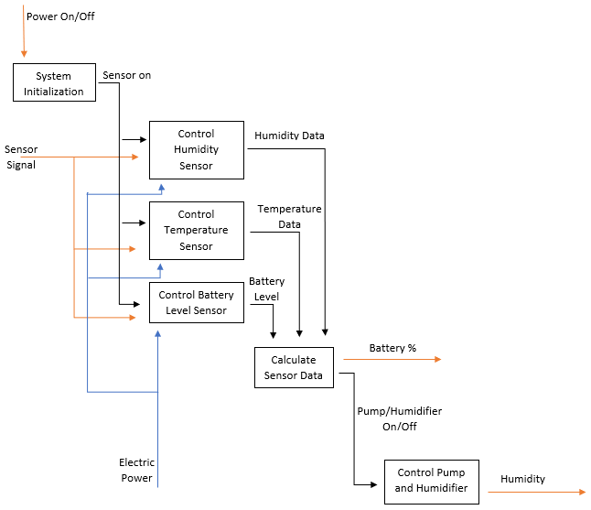
Fig. 3 System design level 1

Level 2

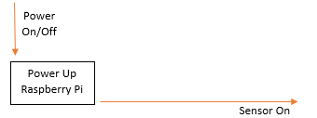
Fig. 4 System design level 2, system initialization

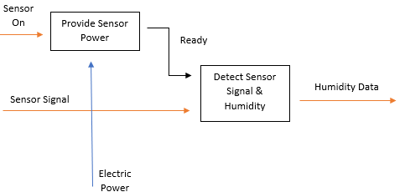
Fig. 5 System design level 2, control humidity sensor

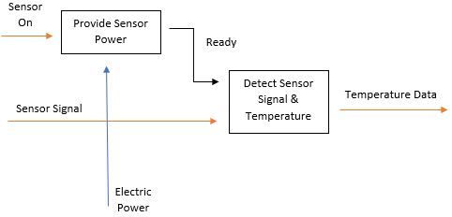
Fig. 6 System design level 2, control temperature sensor

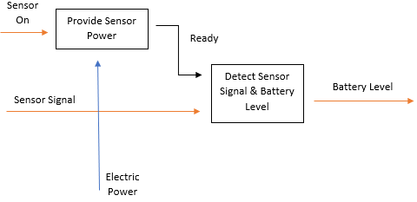
Fig. 7 System design level 2, control battery level sensor

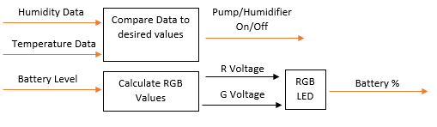
Fig. 8 System design level 2, calculate sensor data

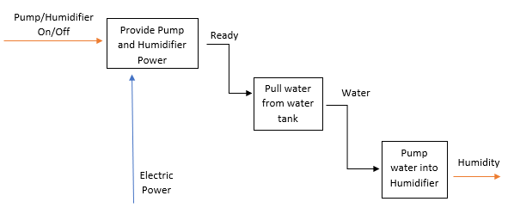
Fig. 9 System design level 2, control pump and humidifier

- System architecture
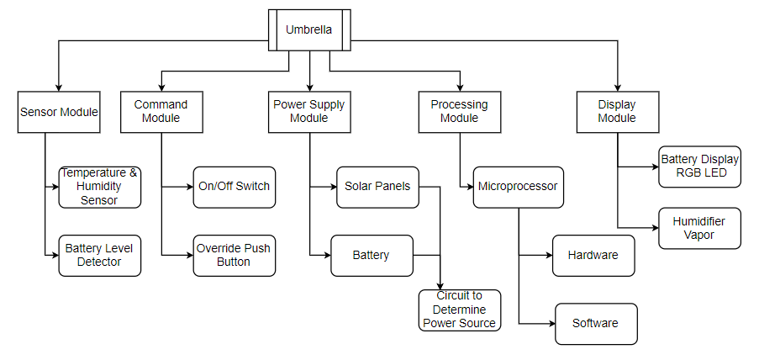
Fig. 10 System architecture, Generic physical architecture

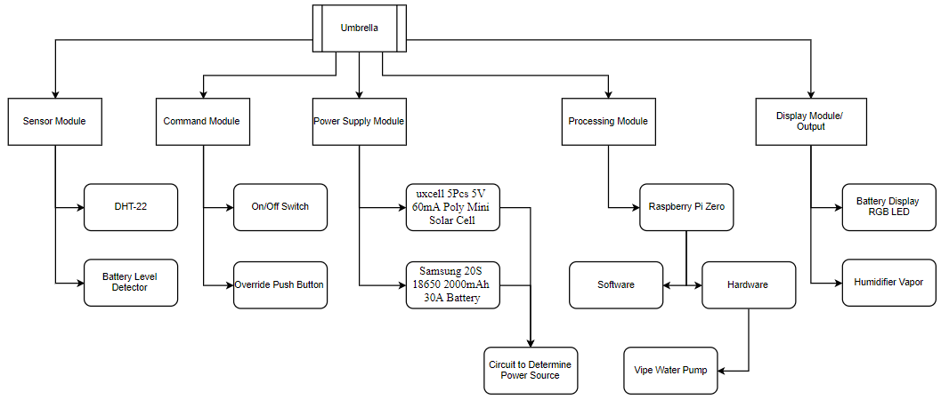
Fig. 11 System architecture, Specific Physical Architecture

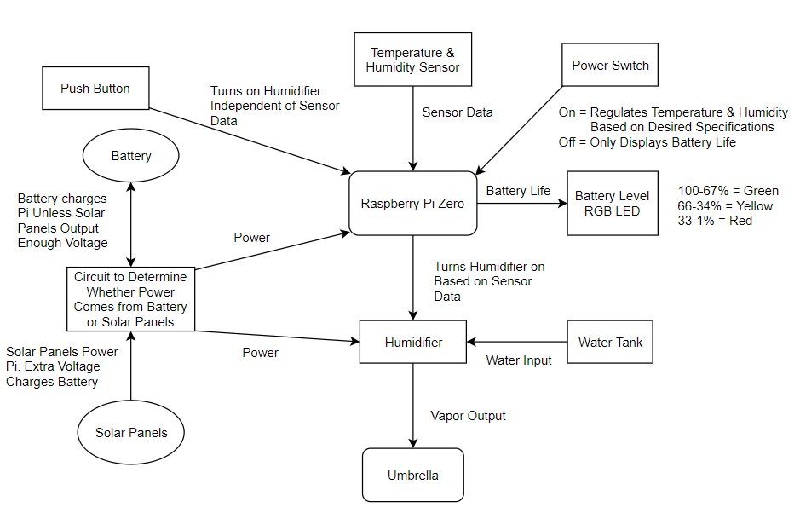
Fig. 11 System architecture, System Architecture

PRELIMINARY EXPERIMENT PLAN
Mission requirement
The device shall adjust the relative humidity and temperature under the umbrella.

Operational requirement
The device shall work as a regular umbrella and the humidifier will be operated with a push button.
Functional requirement
(1) The humidifier will keep the humidity, under the umbrella, within 30-60% while the user is walking for two hours.
(2) The temperature under the umbrella should remain between 65-70 °F while the user is walking for two hours.

Experiment #1: (Mission Requirement evaluation)
Goal: To evaluate the humidity and temperature control
System components: Humidifier, Humidity sensors, Raspberry Pi, PC
Testing Process:
(1) After the humidifier is turned the humidity rating sensor values and temperature will be continuously measured with a PC through the Raspberry Pi
(2) The data will be collected for an hour
(3) The data collection will be repeated three times
Data processing and Visualization: The raw humidity rating sensor will be displayed over time to represent a steady humidity rating over a long period of time. The raw temperature values, under the umbrella, will be plotted against the ambient temperature over time. The deviation from the mean for both the humidity and temperature will be calculated.
Evaluation: Verify that the humidity rating is constant throughout the data collection period. Verify the temperature under the umbrella is below the ambient temperature.

Experiment #2: (Operation Requirement evaluation )
Goal: To evaluate human-device operation of operation using a push button as well as opening and closing the umbrella.
System components: Humidifier, Humidity sensors, Raspberry Pi, Umbrella
Testing Process:
(1) Push button turns on and off the umbrella at any time while the umbrella is open
(2) The user can easily open and close the umbrella
Data Collection: The states of the humidifier will be recorded. No numerical data will be collected for the opening and closing of the umbrella.
Evaluation:
(1) The on/off states will be verified
(2) Focus on the difficulty to open and close the umbrella.

Experiment #3: (Functional Requirement A evaluation )
Goal: To verify the humidity remains within 30-60% range will the user is walking
System components: Humidifier, Humidity sensors, Raspberry Pi, PC
Testing Process:
(1) The user turns on the humidifier and begins to walk at a leisurely pace
(2) Humidity rating will be monitored while the user is in motion with a PC through the Raspberry Pi
(3) Data collection on the PC will take 30 minutes
(4) Data Collection is repeated three times
Data Processing and visualization: Data collected will be graphed over time, the deviation from the mean will be calculated.
Evaluation: Focus on the deviation from the mean and verify the humidity rating is sufficiently steady.

Experiment #4: (Functional Requirement B evaluation)
Goal: To verify the temperature is between 65-70 °F under the umbrella.
System components: Humidifier, Humidity sensors, Raspberry Pi, PC
Testing Process:
(1) The user turns on the humidifier and begins to walk at a leisurely pace
(2) Temperature will be monitored while the user is in motion with a PC through the Raspberry Pi
(3) Data collection on the PC will take 30 minutes
(4) Data Collection is repeated three times
Data Processing and visualization: Data collected will be graphed over time, the deviation from the mean will be calculated. The ambient temperature will be plotted as well to visualize the temperature difference.
Evaluation: Focus on the deviation from the mean and verify the temperature under the umbrella is stays between 65-70 °F.

PRELIMINARY PROJECT PLAN
list of tasks for ECE 493 (9 scheduled weeks + 4 flexed weeks = 13 weeks)

Stage one (one week):
1. Materials prepare and purchase
Materials test and repurchasing.
2. Soft crafting preparation
Knowledge picking up and pre-learning.

Stage two(Three weeks):
3. Umbrella structure and circuit design and craft.
simulations and design whole system circuit; components set up which include the 3D print components.
4. Power system design and craft.
Solar panel placement and power supply distribution.
5. Control system design and craft.
Raspberry Pi programing and sensors connection testing.
6. Cooling system design and craft.
Humidifier assembling and cooling level testing.

Stage three(one week):
7. Components integration.
Integrate all components together.
8. Fault testing.
Experimental plan execution.

Stage four(two weeks):
9. Problems debugging.
10. Finalizing devices.

Stage five (two weeks)
11. Presentation practice.
12. Report and poster drafting.

POTENTIAL PROBLEMS
1. Reducing the temperature under the umbrella to 65-70 °F will be a challenge due to being outdoors. The cool humidity provided by the umbrella will be constantly diffusing into the surrounding environment.
2. The electrical components may overheat in the hot weather when used for extended periods of time
3. A potential problem for the solar panels and battery is having the system be waterproof. Since the solar panels are located on the exterior of the umbrella, they might have rain exposure which could damage the circuitry.
4. The solar panels may get in the way of folding the umbrella
5. The rod of the umbrella structure may not have sufficient space to run all of the wiring required for the Raspberry Pi forcing us to design our own umbrella structure.
6. Evaporative cooling may not be efficient in a real-world scenario causing us to implement another cooling method such as adding a fan to accelerate evaporative cooling.
7. The water pump may burn out if it is run with no water.
8. The water pump might not be modified to provide the water speed that is capable for the nebulizers to operate.
9. Since the water pump is small, the intake flow rate might not be as high as we would want as a result would decrease our maximum head lift.
10. User’s hair might be entangled with the integrated fan.

EXISTING PATENTS
When designing this product, it is important to consider products that already exist. This section will analyze current patents and what is specific to their umbrella design. There are currently three different patented products that incorporate a humidifying aspect into an umbrella.
First is the Sun-rain umbrella with humidifier [17]. This design consists of an ultrasonic transducer as the humidifier, a water tank, a battery, a fan, and an on switch. All the parts are located at the base of the umbrella. The ultrasonic transducer is what creates the water vapor, getting its water supply from the water tank. After the vapor is created, the fan pushes the mist up the shaft of the umbrella and out a nozzle underneath the canopy. The battery can be recharged and is used to power the transducer and fan when the switch is turned on. Overall, this umbrella supplies shade on a sunny day with the ability to increase the humidity. It is not portable, for the base is large and bulky.
The next patented product is the Umbrella with humidification function [18]. This design consists of an ultrasonic atomizer as the humidifier, a water tank, a battery, a power switch, and an infrared remote. Something unique to this design is the humidifier snaps onto the shaft of the umbrella. This allows the user to place the humidifier at their desired location. Also, the remote control or the power switch is used turn the humidifier on and off. The water is connected to the humidifier through a receiving chamber.
The third product is the Bionic leaf humidifying sunshade umbrella [19]. It uses an ultrasonic humidifier, a water tank, a battery, a fan, and a double-layered canopy material. The canopy material is the focus of this patent and serves as UV protection from the sun. Additionally, the umbrella is portable, though it is very bulky in weight. It uses a 4-pound water tank as well as a 24 DC voltage supply. The moisture generator and power device are located on the upper portion of the umbrella shaft, while the water tank and circuitry are located at the bottom.

IX. References
- Aosong Electronics Co.,Ltd, “Digital-output relative humidity & temperature sensor/module.” Accessed: Oct 13, 2019. [Online]. Available: https://www.sparkfun.com/datasheets/Sensors/Temperature/DHT22.pdf

- Amazon, “Adafruit AM2302 (wired DHT22) temperature-humidity sensor [ADA393].” Accessed: Accessed: Oct 13, 2019. [Online]. Available: https://www.amazon.com/Adafruit-AM2302-temperature-humidity-sensor-ADA393/dp/B00SK6940I

- Raspberry, “Raspberry Pi Zero.” Accessed: Accessed: Oct 13, 2019. [Online]. Available: https://www.raspberrypi.org/products/raspberry-pi-zero/

- Amazon, “Anself Ultra-quiet Mini DC12V Micro Brushless Water Oil Pump 240L/H 5W Lift 3M.” Accessed: Accessed: Oct 13, 2019. [Online]. Available: https://www.amazon.com/Anself-Ultra-quiet-DC12V-Micro-Brushless/dp/B00OIHLUFA

- Amazon, “Vipe Mini Micro Submersible Motor Pump Water Pumps DC 3-6V 120L/H Low” Accessed: Accessed: Oct 13, 2019. [Online]. Available: https://www.amazon.com/Vipe-Micro-Submersible-Motor-Water/dp/B01N0X3CW4

- Amazon, “uxcell 5Pcs 5V 60mA Poly Mini Solar Cell Panel Module DIY for Phone Light Toys Charger 50mm x 43mm.” Accessed: Accessed: Oct 13, 2019. [Online]. Available: https://www.amazon.com/uxcell-Solar-Panel-Module-Charger/dp/B073Y8P2CF

- 18650batterystore, “Samsung 20S 18650 2000mAh 30A Battery.” Accessed: Accessed: Oct 13, 2019. [Online]. Available: https://www.18650batterystore.com/18650-p/samsung-20s.htm

- Amazon, “Comidox 2PCS Ultrasonic Mist Maker Transducer Fogger Ceramics Discs Humidifier Diffuser Replacement Parts DIY Kits D16mm 113KHz DC 5V 300mA.” Accessed: Accessed: Oct 13, 2019. [Online]. https://www.amazon.com/Comidox-Ultrasonic-Transducer-Humidifier-Replacement/dp/B07P8C5V7W/

- AliExpress, “Bonding Wire 7*9*17 Micro/Mini DC Motor High Speed 1.5-3V Electric Motors Solar Energy for DIY Toy Accessories.” Accessed: Accessed: Oct 13, 2019. [Online]. https://www.aliexpress.com/item/32973941603.html?spm=a2g0o.productlist.0.0.12873d8evFXyX1&algo_pvid=55c79393-a3db-4105-837d-a4dca51d1518&algo_expid=55c79393-a3db-4105-837d-a4dca51d1518-13&btsid=cfcc7fda-d7eb-476c-b09f-bf5c351510ff&ws_ab_test=searchweb0_0,searchweb201602_6,searchweb201603_55

- Mouser, “DHT11 Humidity &Temperature Sensor.” Accessed: Oct 13, 2019. [Online]. Available: https://www.mouser.com/datasheet/2/758/DHT11-Technical-Data-Sheet-Translated-Version-1143054.pdf

- Amazon, “JIANG Flexible Solar Panel Solar Power Charger Thin Film DIY 1W 6V Photovoltaic Cells (Yellow).” Accessed: Abr. Mon. xx, 2019. [Online]. Available: https://www.amazon.com/s?k=jiang-Flexible-Charger-Photovoltaic-Yellow

- Amazon, “Anker PowerCore 5000 Portable Charger, Ultra-Compact 5000mAh External Battery with Fast-Charging Technology, Power Bank for iPhone, iPad, Samsung Galaxy and More.” Accessed: Abr. Mon. xx, 2019. [Online]. Available: https://www.amazon.com/Anker-PowerCore-Ultra-Compact-High-Speed-Technology/dp/B01CU1EC6Y

- Fondriest, “Solar Radiation & Photosynthetically Active Radiation.” Accessed: Accessed: Oct 13, 2019. [Online]. Available: https://www.fondriest.com/environmental-measurements/parameters/weather/photosynthetically-active-radiation/#targetText=Solar%20radiation%20is%20radiant%20(electromagnetic)%20energy%20from%20the%20sun.&targetText=The%20three%20relevant%20bands%2C%20or,visible%20light%20provides%2042.3%25%209.

- Khan Academy, “Specific heat, heat of vaporization, and density of water.” Accessed: Oct 13, 2019. [Online]. Available: https://www.khanacademy.org/science/biology/water-acids-and-bases/water-as-a-solid-liquid-and-gas/a/specific-heat-heat-of-vaporization-and-freezing-of-water#targetText=Heat%20of%20vaporization%20of%20water,-Just%20as%20it&targetText=That%20is%2C%20water%20has%20a,%C2%B0C%2C%20water's%20boiling%20point.

- Sciencing, “Why Does Humidity & Wind Speed Affect Evaporation?.” Accessed: Accessed: Oct 13, 2019. [Online]. Available: https://sciencing.com/humidity-wind-speed-affect-evaporation-12017079.html
- Amazon, “Bonai 4 Packs 2800mAh AA Rechargeable Batteries 1.2V Ni-MH Low Self Discharge - UL Certificate.” Accessed: Oct 17, 2019. [Online]. Available:
https://www.amazon.com/BONAI-Rechargeable-Batteries-2800mAh-Discharge/dp/B072DTNL5W/ref=sr_1_1?keywords=nihm%2Bbattery%2Bhigh%2Bvoltage&qid=1571365041&sr=8-1&th=1
- Patents.google.com. (2019). CN103892540A - Sun-rain umbrella with humidifier - Google Patents. [online] Available at: https://patents.google.com/patent/CN103892540A/en
- Patents.google.com. (2019). CN202819897U - Umbrella with humidification function - Google Patents. [online] Available at: https://patents.google.com/patent/CN202819897U/en
- Patents.google.com. (2019). CN201709596U - Bionic leaf humidifying sunshade umbrella - Google Patents. [online] Available at: https://patents.google.com/patent/CN201709596U/en

