Cooling Humidifier Umbrella for Lung Cancer and Multiple Sclerosis Patients
Progress Report #1

Faculty Supervisor: Nathalia Peixoto
Course Coordinator: Peter W. Pachowicz
Team members: Christopher R Aitken, Jaime Martinez Diaz, Jason J Schwarzwalder, Christopher J Barry, Yizhe Wang, Yunke Chen

Table of Contents

- Technical Section
  - Testing of Cooling System - 2
  - Testing of 3D Printed - 3
  - Testing of Power System - 5
  - Testing of Control System - 5
- Administrative Section
  - Progress summary table - 6
  - Funds spent and Man-hours - 6
- Plans for the next reporting period
  - Power System - 7
  - Cooling System - 7
  - 3D Printed Parts - 8
  - Control System: - 8
- Ending - 8

Technical Section:
This section shows the description of progress for each task/subtask of the WBS undertaken and results achieved in the reporting period.

Testing of Cooling System:
- Cooling From Humidifier and Fan
  - Humidifier Testing

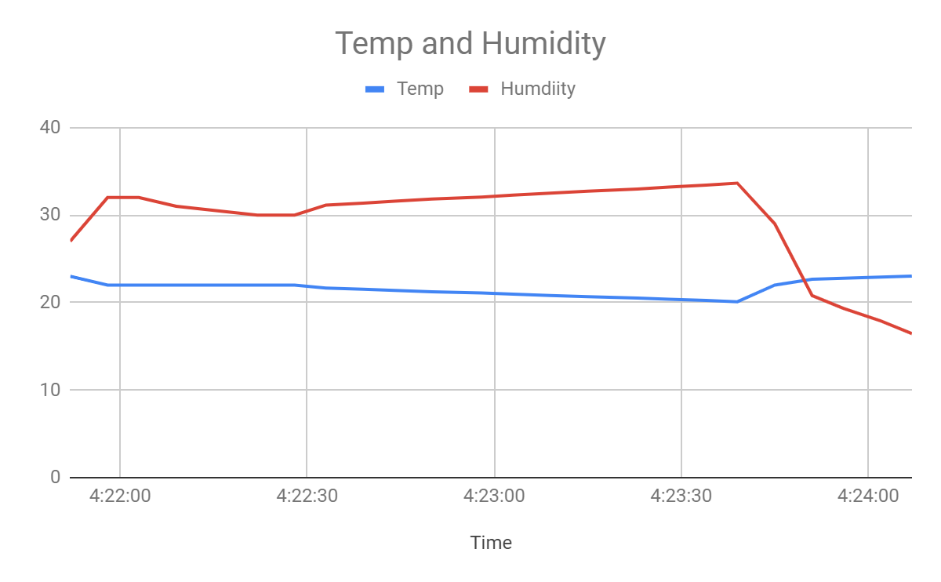
Figure.1
The amount of cooling that the atomizer can provide is not significant. There is little decrease in temperature over time, where the starting temperature was 23℃ and the end temperature 20℃. The relationship between the relative humidity and the temperature is observed in which the temperature decreases as the humidity increases. The testing location was in a closed room room with a temperature of 23℃ and a relative humidity of 30%. The amount of temperature decrease in less humid environment has not been tested due to the lack of available environments with hot and dry climates.

  - Fan Testing
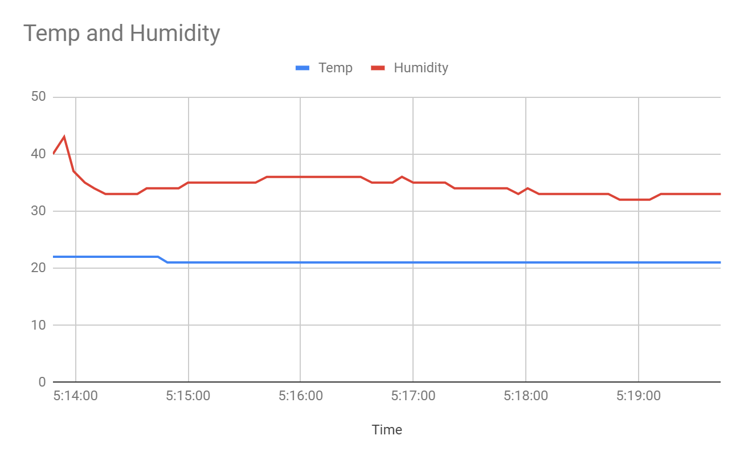
Figure.2
Implementing the cooling system with both the humidifier and fan, there is no notable decrease in temperature around the immediate area. The final temperature for the the testing process resulted in 20℃ with a relative humidity of 30%. The fan did not improve the performance of the cooling system. The distance from which the temperature and humidity were read was seven inches from the fan. The lack of improvement from the fan might be due to the fan imprecisely distributing the misting area onto the measuring system. Testing four fans with a humidifier simultaneously hasn’t been tested yet, there is no expectation that the amount of cooling will improve drastically but the multiple humidifiers could decrease the temperature by increasing the humidity.

- Lifting Range of Water Pump

Lift Range(inches) | Water Rate with Regular Water | Water Rate with Chilled Water
47 | 8.89ml/s | 6.67ml/s
Table.1

The amount of lifting range for the water pump meets the requirement of the height for the umbrella. The water rate is acceptable for the purpose of damping the sponge in the cooling system enclosure. There will have to be some manipulation of how long the water pump has to be on in order to prevent the cooling system inclosure from overfilling. The change in water rate for chilled water was surprising, where the water rate decreased.
Testing of 3D Printed:
- Handle and water pump support
The water bottle support is fully designed and printed out into two parts. In testing these parts each part did not break in stress tests and drop tests. In our first test we dropped each part from 5 feet 3 times to see if they break at all in which we did not see any damage. The reason we chose 5 feet was in everyday use these pieces shouldn’t be dropped from a height higher than 5 feet. In addition, we tested these parts by using them in similar ways the user would and no issues came up where they would break off of intended use.
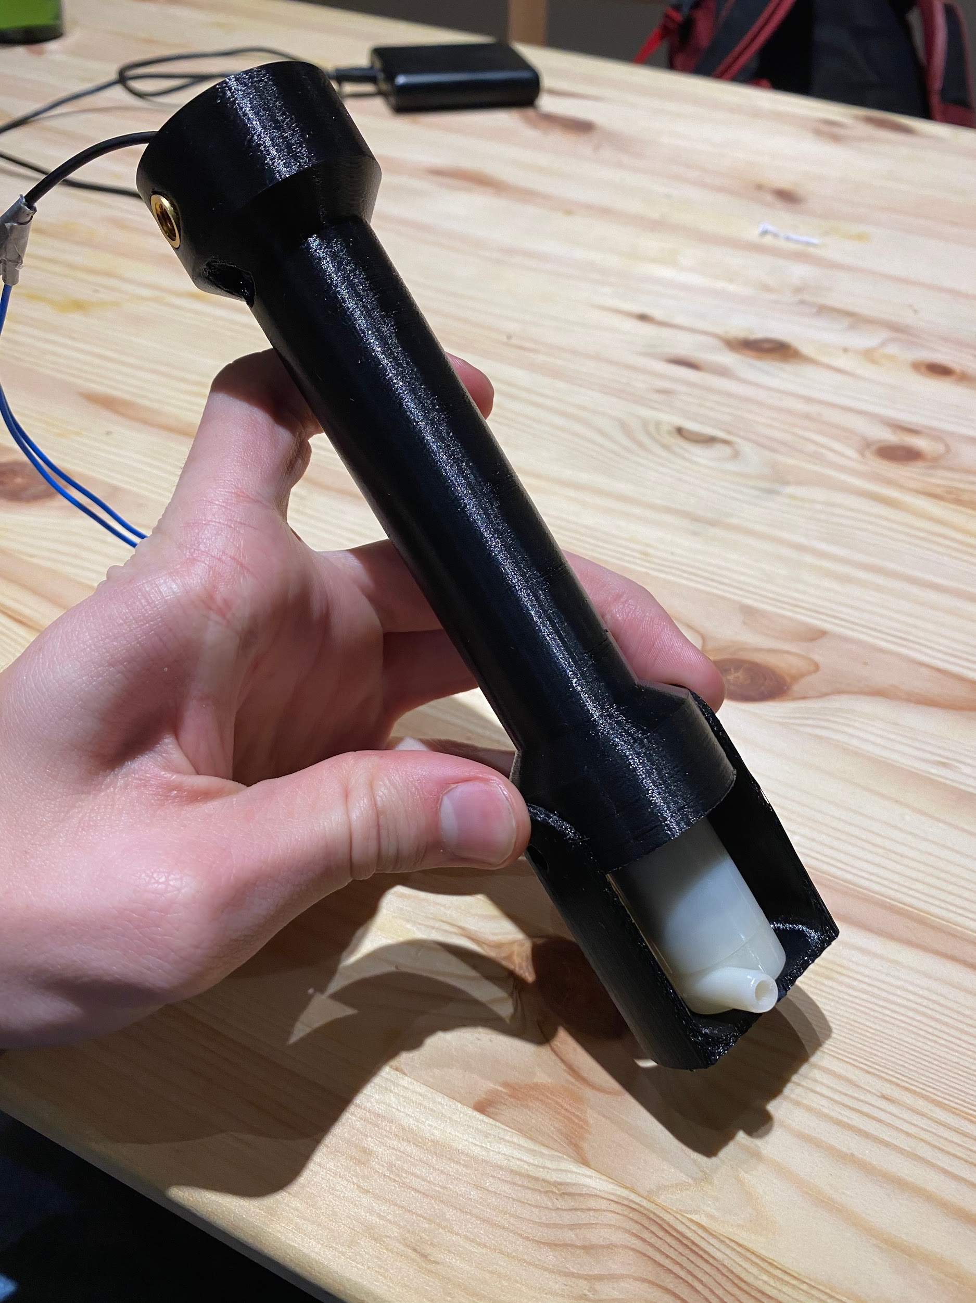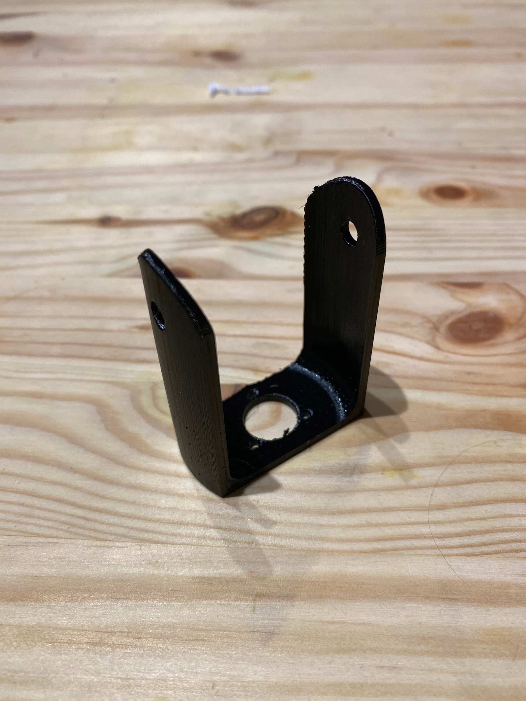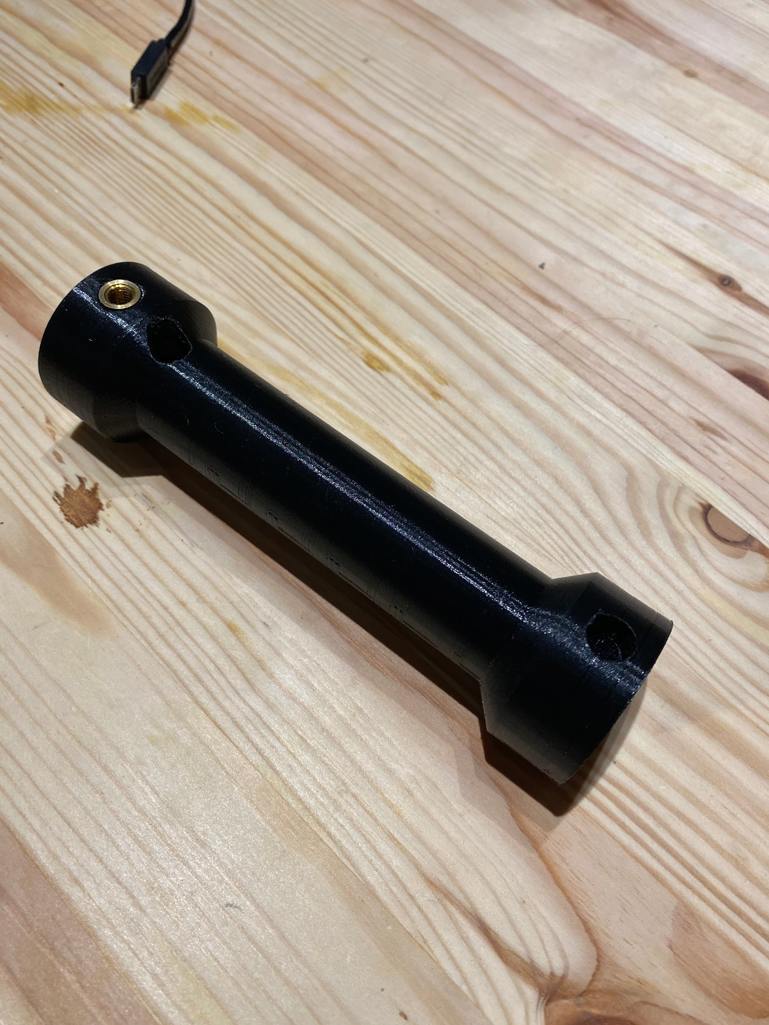
Figure.3 Figure.4 Figure.5
- Ferrule
The ferrule testing is mainly focusing on the PLA material durability vs. infill density. When the sample ferrule’s infill quality set as 20% the ferrule is durable and the printing estimating time is 11 hours and 25 minutes. To do the compareation, I printed the same structure with an infill density of 10%. As a result, I got a printed ferrule with a similar durability and a lower printing time. For the10% density structure, the printed time reduced to 7 hours and 20 minutes. Therefore, for the further printing of the Ferrule part, The printing value should set as 10% infill density with the octet pattern.
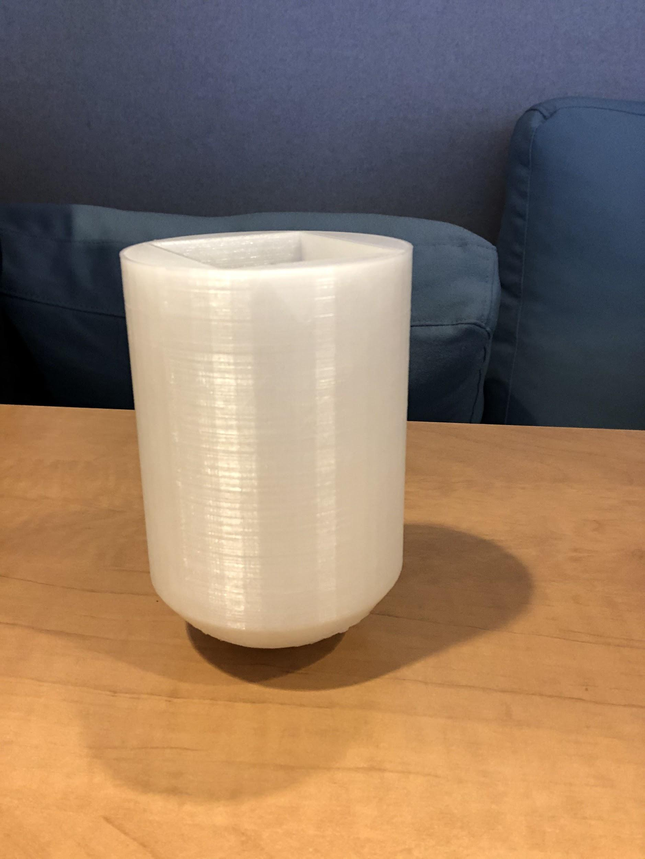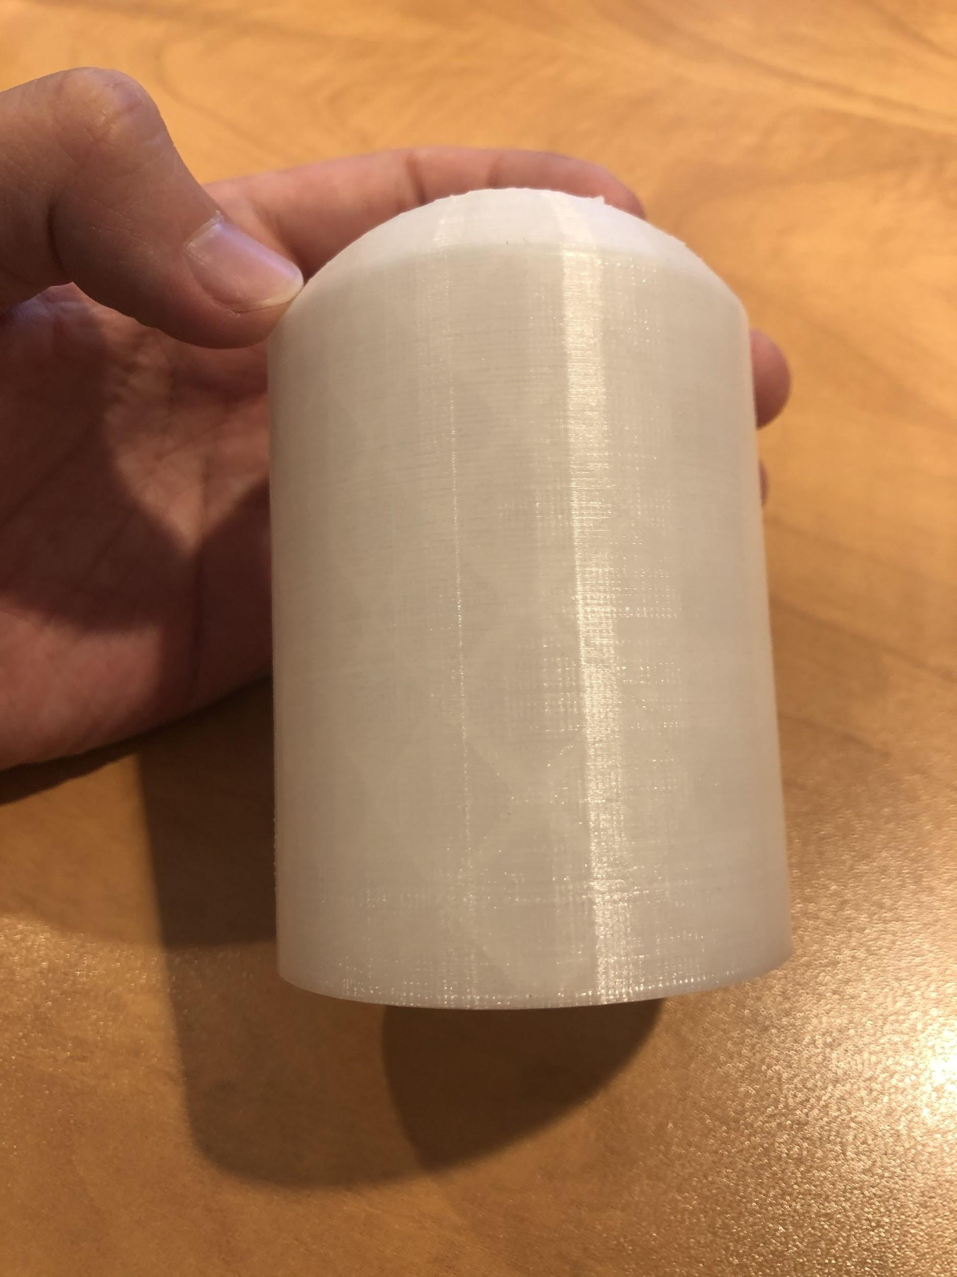
Figure.6 Figure.7

Testing of Power System:
- Voltage output of both the batteries and solar panels were tested. The 4 solar panels were connected in parallel with a voltage output of 8.5 volts. The voltage output of the batteries were 3.56 volts each.
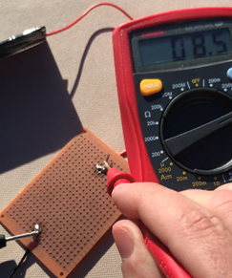
Figure.8

Testing of Control System:
- The raspberry pi can request data from the dht11 and use it to turn components on and off. This currently works for the dc motor and the humidifiers. The pictures below show the setup used to test the code. LEDs were used at the time to test the code and make sure pins were turning on and off at the correct times. Both pictures are while the code is running. Red was being used to test the DC motor’s pins and Yellow was for the humidifiers. The DC motor is using pulse width modulation to turn on and off.
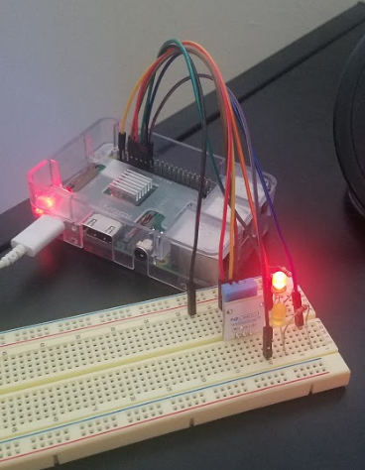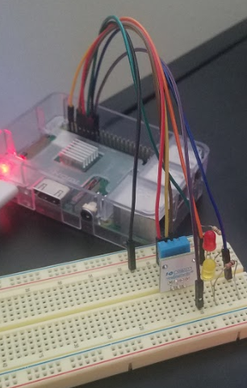

Figure.9 Figure.10

Administrative Section:

Progress summary table
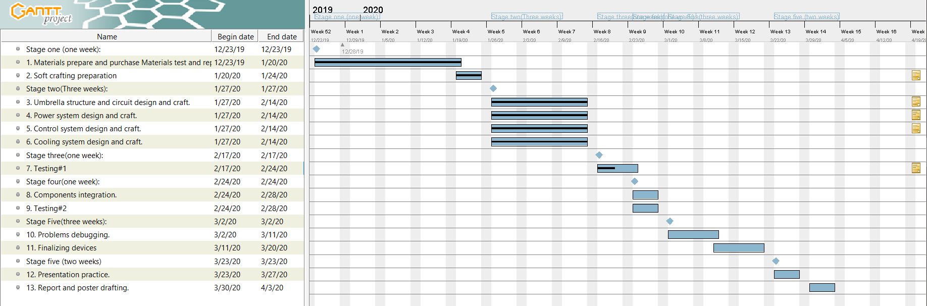
Funds spent and Man-hours

- Cooling System:
Man-hours: 27 hours
Funds spent: Motors and fan blades: $10; Pumps with water tubes: $2; Humidifiers with controllers: $11; micro USB headers: $10; 3D printing filament: $3.3;
Total funds spent: $36.33

- Prints (Handle and water pump support)
Man hours: 25 hours
Funds spent: $1.55 for 68 grams of filament

- Prints (Ferrule)
Man hours: 15 hours
Funds spent: $1.5 for 66 grams of filament.

- Power System:
Man-hours: ~ 12 hours
Funds spent: Batteries $13.98; Solar panels $8.69; Total $22.67

- Raspberry Pi Control System:
Man-hours: ~11 hours
Funds: Pi Zero $10.58, DHT11 $7.40, Wires $5.19
Total funds spent: $23.17

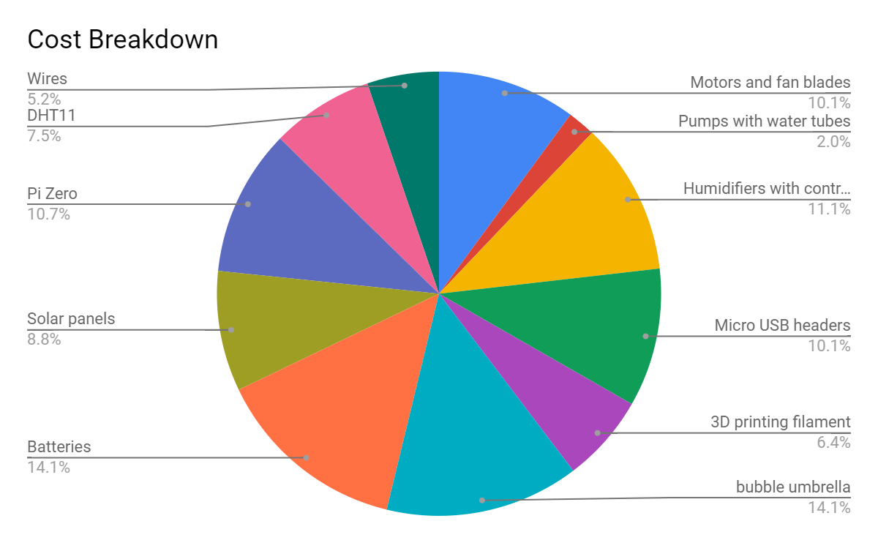

Total funds spent (by 2/21/2020) : $99.19
Total man-hours（from 1/21/202 to 2/21/2020: 90hours

Plans for the next reporting period
This section shows the follow up tasks that to work on for the next period.

- Power System
For the next reporting period, I will be working on code that will determine whether the solar panels or the batteries will be powering the umbrella. I will purchase a battery charger that will charge the batteries when the umbrella is not in use to ensure the batteries are fully charged before using the umbrella. Since there isn’t much more to be done for the power systems planning and testing, I will help with other aspects that will require more time. A problem area to be solved is connecting the solar panels and batteries to raspberry pi. I will have to research the internal wiring of a micro USB cable and how it would connect to the power system.

- Cooling System:
Testing the four fans simultaneously still has to be tested in order to observe if there are any improvements in the cooling system. A fully functioning umbrella still has to be tested in order to determine the overall temperature reduction that will be achieved from the cooling system. Improvements on the cooling system enclosure needs to be made in order to reduce the area, for a more compact closed umbrella.Currently the enclosure is 2 x 4 in enclosure that will be attached to the ribs of the umbrella. Being able to reduce the width of the fan blades would allow us to accomplish this but may result in reduced the airflow of the fan. The alternative design with a collapsable center fan may be needed to improve the bulky build of the umbrella. An accurate form of determining the moisture of the sponge still has to be implemented for the pi zero to make an appropriate decision to when to remoisturize the sponge.

- 3D Printed Parts
- Handle and water pump supports
The Handle is currently designed and needs to be resized in a few locations before it can be printed. It will go through similar durability tests as the other parts that have already been printed. In addition the two parts already printed need to go through water submerged tests to make sure they will be able to stay durable while submerged. In addition, to the 3D printed handle we will need to incorporate a switch onto it once it is printed.
- Ferrule
The goal of the ferrule design is to contain two batteries, one raspberry pi zero board, two H-bridge motor modules and one relay for atomizers. For Now, ferrule has set a great space and printing structure to contain all of the components. The next step, I will focus on the connection between the ferrule and umbrella to ensure inner components stable for use.

- Control System:
The python file does not boot on startup right now. The current method used to get it to boot on startup does not work. I will need to try a different method. The current solution I am going to test is to have a script boot on startup that then runs the python file. The other issue is that there is no way to currently measure the water level in the sponge. This is a problem because the pumps only need to send water up to the sponge if it is running out of water. I can not find a sensor that immediately seems like it would be able to detect water levels in a sponge.

End with Questions: .
a) Is the project on schedule?
b) Are there any problem areas causing project delays, etc.?
c) Plan to deal with problems/delays.
Control System:
There are two major things that are not currently the only schedule. Booting on startup and pump control. Booting on startup should be an easy fix but the pump control is a problem that I have not found a solution to yet. I just need to find a sensor that can read the water level in the sponge and the problem will go away.
Everything else is on schedule. There aren’t any foreseeable items that would create a delay.

